



FALCON’s Response to Amazon

For Supply of Spring Loaded Bins

September 5, 2025
Kind Attention – Ms. Sneha Sawant

M/s Amazon

Offer Ref: F25-00281 ; Date : 9/5/2025

Subject – Techno-commercial Offer for Spring Loaded Bins

Dear Team,

We are pleased to submit our Techno-commercial Offer in response to your RFQ.

As you will note, we have studied your requirements in great depth and, along with the information collected during the workshops and calls with you, we have put together a detailed technical proposal laid out in various sections and sequenced to enable you to understand our proposed solution and to re-enforce our commitment to be your partner in this strategic initiative.
In subsequent sections, we have highlighted the capabilities and experiences of Falcon Autotech with sections on our Automation Technologies.
To conclude, I would like to add my personal commitment, on behalf of Falcon Autotech. As we move through the RFP process, please do not hesitate to contact me and my team. We will be pleased to assist you for any further information or clarifications that you might have.

Best Regards,

Sandeep Bansal

Chief Business Officer

Response to RFP for Spring Loaded Bins

Proposal Reference – F25-00281

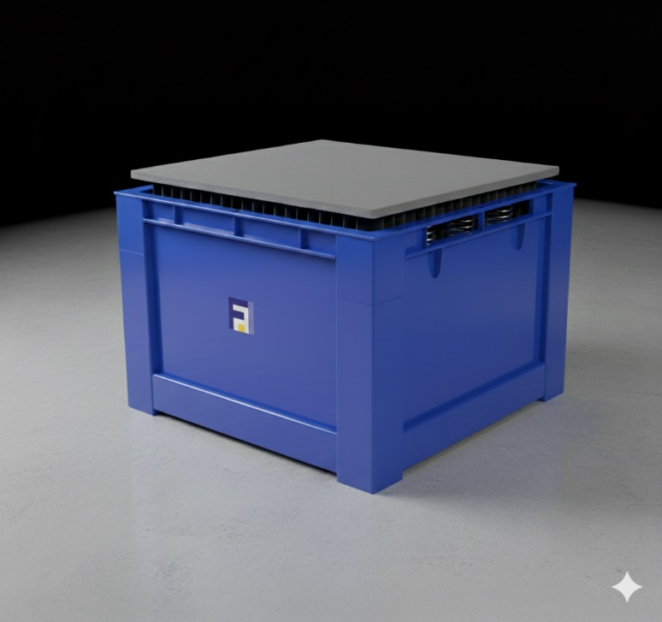

Falcon Autotech Private Limited
Plot No. 87, Sector Ecotech-1, Extention-1, Greater Noida, Uttar Pradesh 201308.

Contact – Sanyog Pratap Singh
Asst. Manager
Mob - +91 8750052591
Sanyog.singh@falconautotech.com

Table of Contents
1. Glossary 5
2. Company Profile 6
3. Proposed Product Description 10
3.1 Objective 10
3.2 Spring Loaded Bins 10
3.3 Technical Specification 11
4. Sope of Supply 12
4.1 Mechanical BOM 12
4.2 Service 12
5. Program Organization 13
5.1 Delivery Schedule 13
6. Commercial Terms 13
6.1 Price Sheet 13
6.2 Payment Terms 13
7. Warranty Period 14

Glossary

S. No. | Term | Description
1 | RFQ | Request For Quote
2 | SLB | Spring Loaded Bins
3 | PPH | Parcels Per Hour
4 | IT | Information Technology
5 | BOQ | Bill Of Quantity
6 | I/O | Input/ Output
7 | PDP | Power Distribution Panel
8 | PC | Personal Computer
9 | UPS | Uninterrupted Power Supply

Company Profile

Falcon Autotech (Falcon) is a global intralogistics automation solutions company. With over 10 years of experience, Falcon has worked with some of the most innovative brands in E-Commerce, CEP, Fashion, Food/FMCG, Auto and Pharmaceutical Industries. With our proprietary software and robust hardware integration capabilities, Falcon designs, manufactures, supplies, implements, and maintains world-class warehouse automation systems globally. Falcon’s strong research and development team and the continuous focus on innovation reflect our strong solution line around Sortation, Robotics, Conveying, Vision Systems and IOT. Falcon has done over 1,800 installations across 15 countries on four continents.

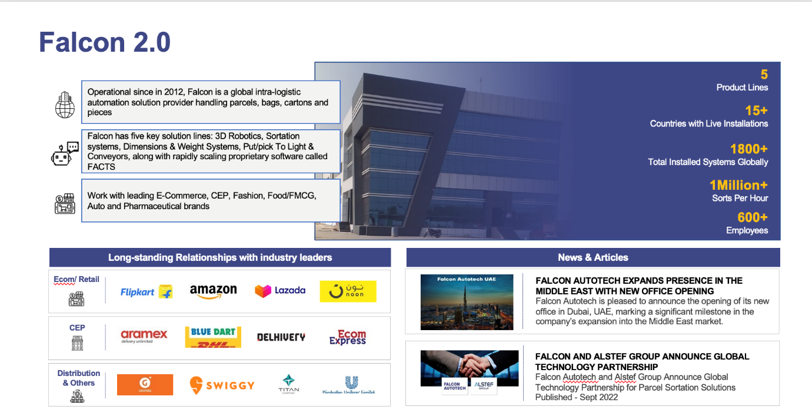

Falcon Autotech is currently among the top 15 intralogistics automation company, our vision is to become top 10 intralogistics automation company in our focused product lines.



The team started out in 2004 solving special purpose automation problems for clients and later established Falcon Autotech in 2012 with strong focus on building standard technology stack spanning across Hardware, Firmware and Software to tackle bigger Supply Chain problems around warehouse automation and material handling. Over the decade, Falcon has made rapid strides and has carved out a niche in some of the world's most cutting-edge technologies: Sortation, Robotics, Conveying, Vision Systems and IOT.

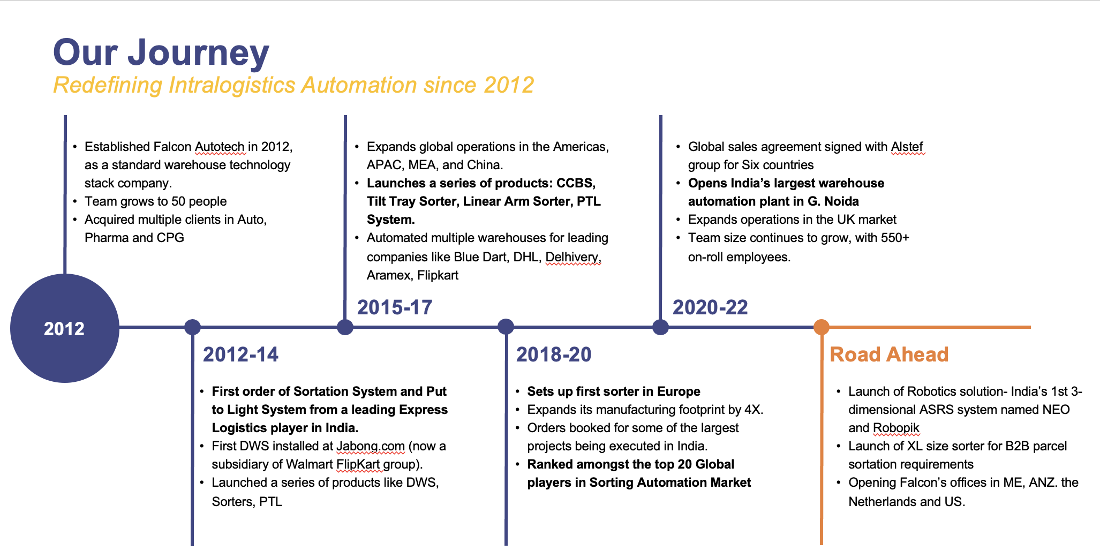

As a leading player in the intra-logistics automation space, Falcon continuously strives to improve the operational efficiencies and accuracies for its clients through its domain knowledge and experience in addition to its wide range of products and solutions. In order to be able to live up to the high expectations set forth by our clients, the team at Falcon realizes the importance of taking up selective applications in focused Industries and deliver world class projects in return.

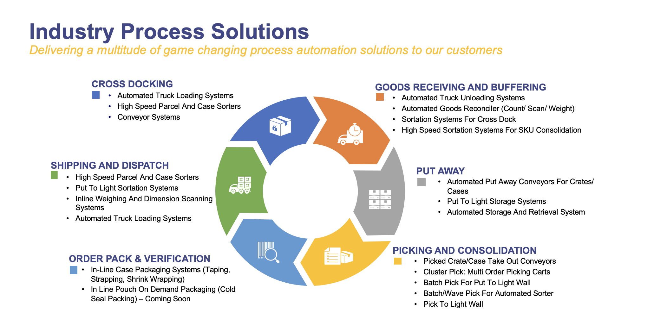

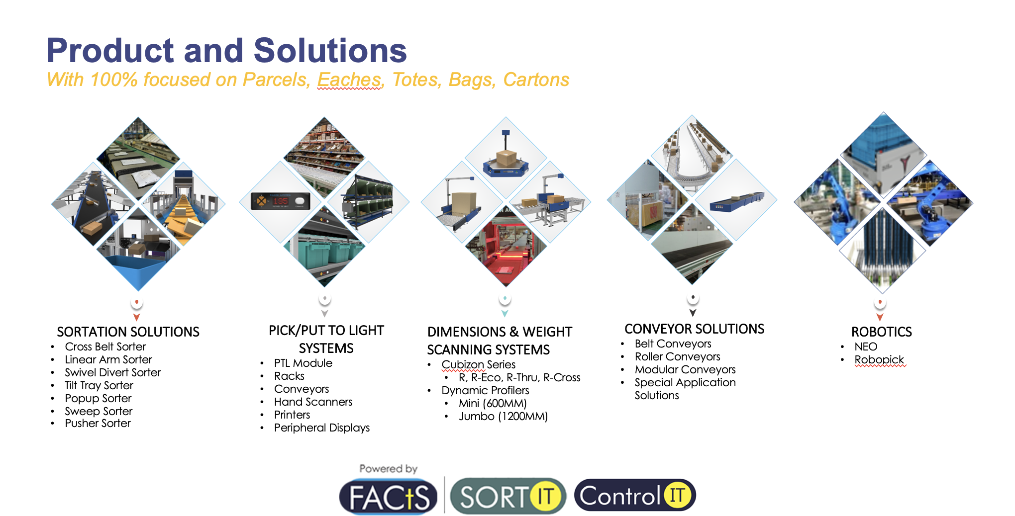

Falcon Autotech has successfully delivered warehouse automation solutions based on smart and innovative combinations of above product lines for effective materials handling, sortation and movement. The process is controlled in real-time by our in house WCS applications. These solutions considerably cut the need for manual operations, improve working conditions and ensure the highest accuracy of the entire process up to final delivery to the recipient.

Over the last 10 years, Falcon has worked with some of the most innovative brands worldwide and has established long standing partnerships. These brands are testimony of our strong focus on delivering superior customer satisfaction and offering end-to-end intralogistics solutions.

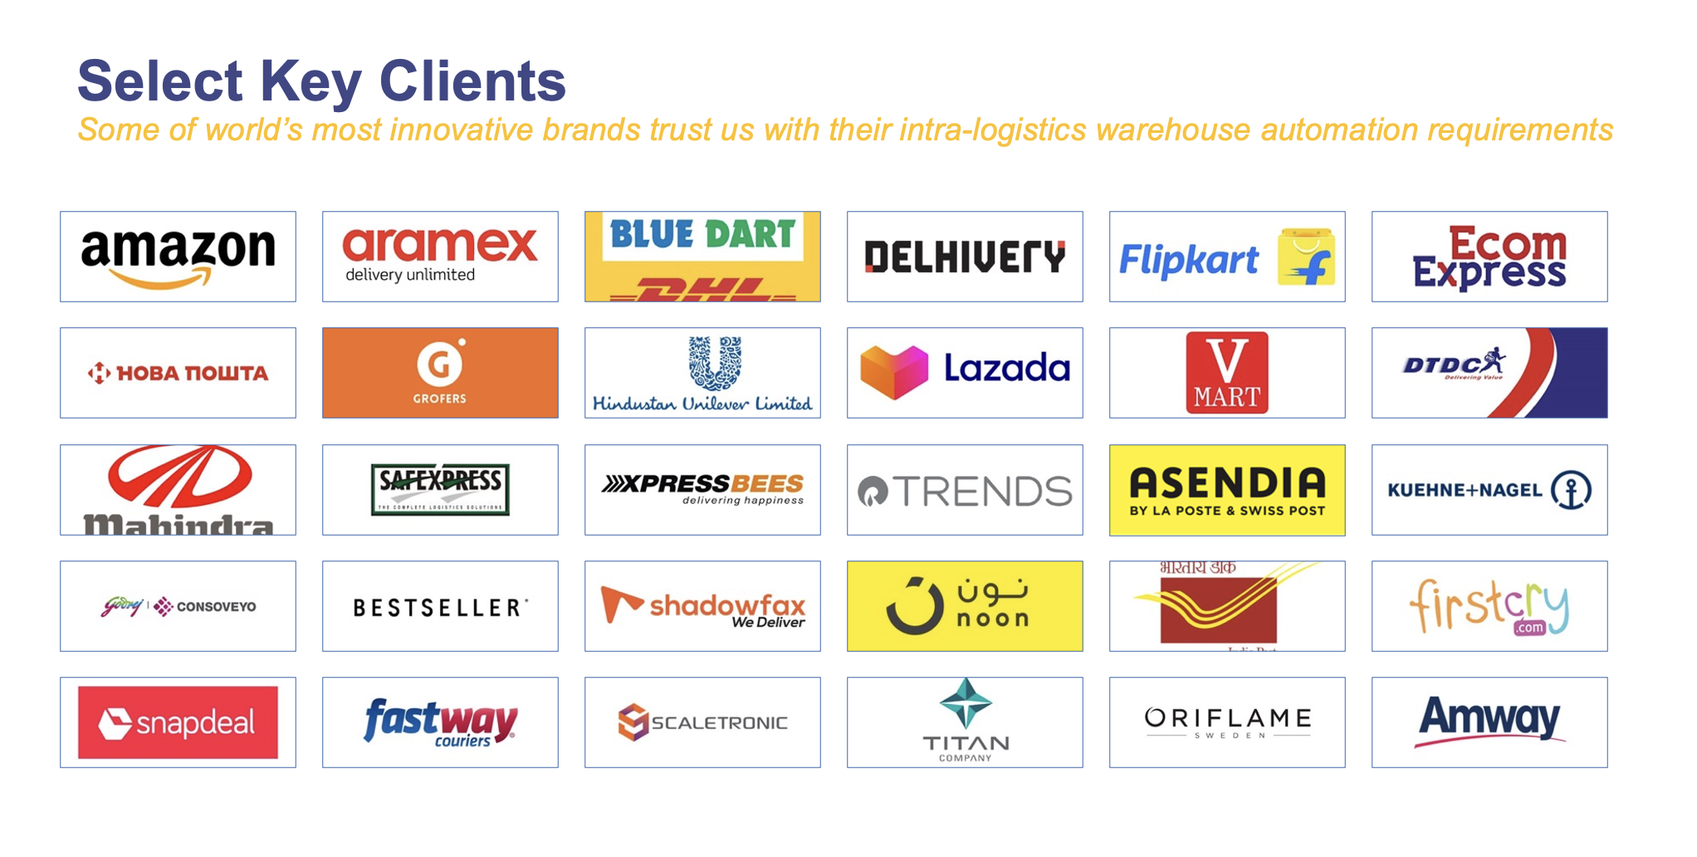

With over 1,800 installations, today Falcon’s systems are used all over the globe. Falcon has highly motivated team of 600+ employees supported by over 15 global partners who help us design, manufacture, deliver and maintain automation solutions globally.

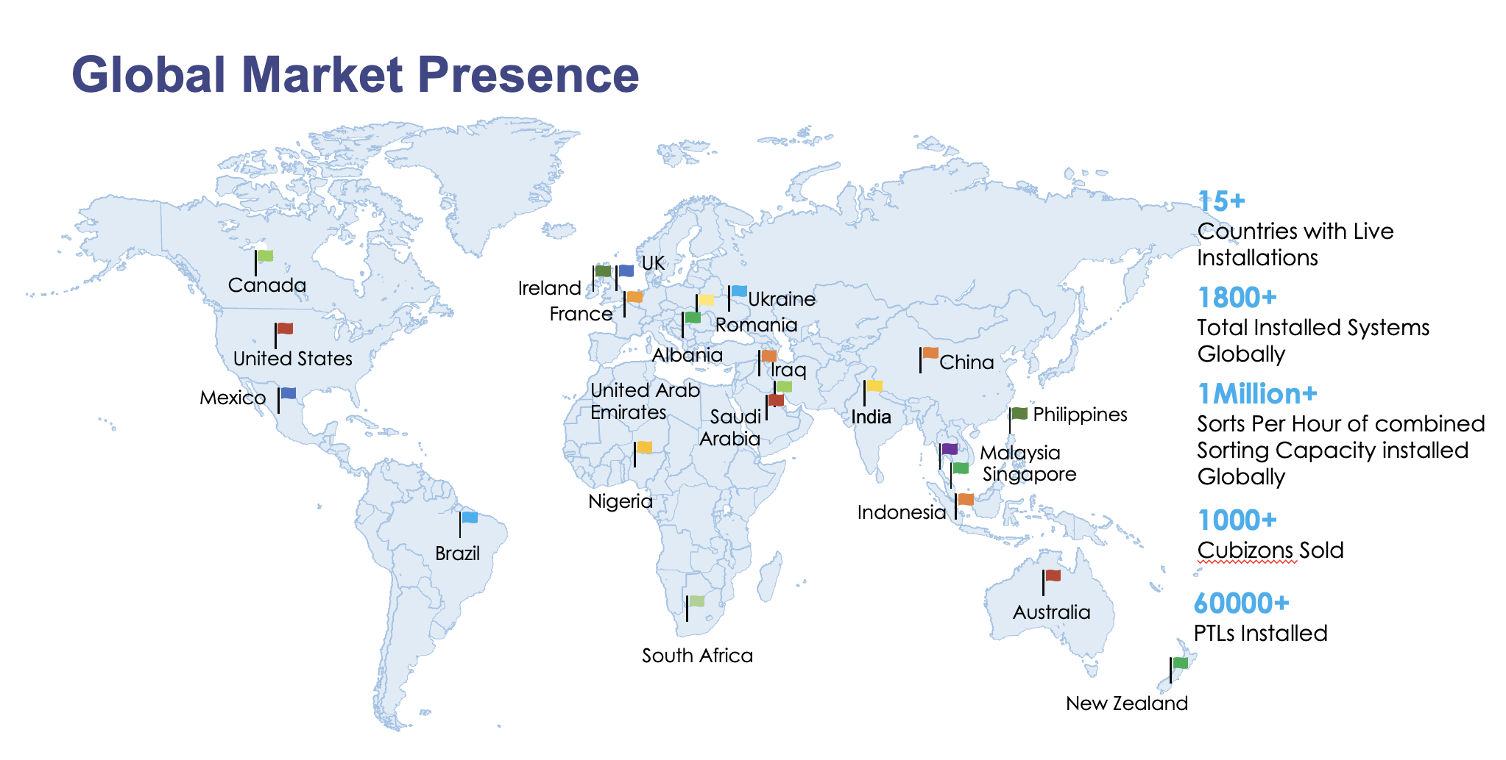

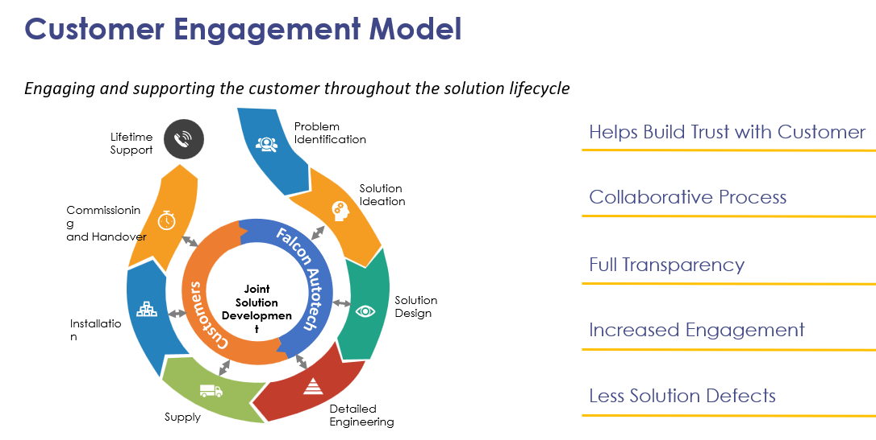

Proposed Product Description

Objective
The purpose of this proposal is to present the design, manufacturing, installation, commissioning, testing and acceptance testing of the Spring Loaded Bins.
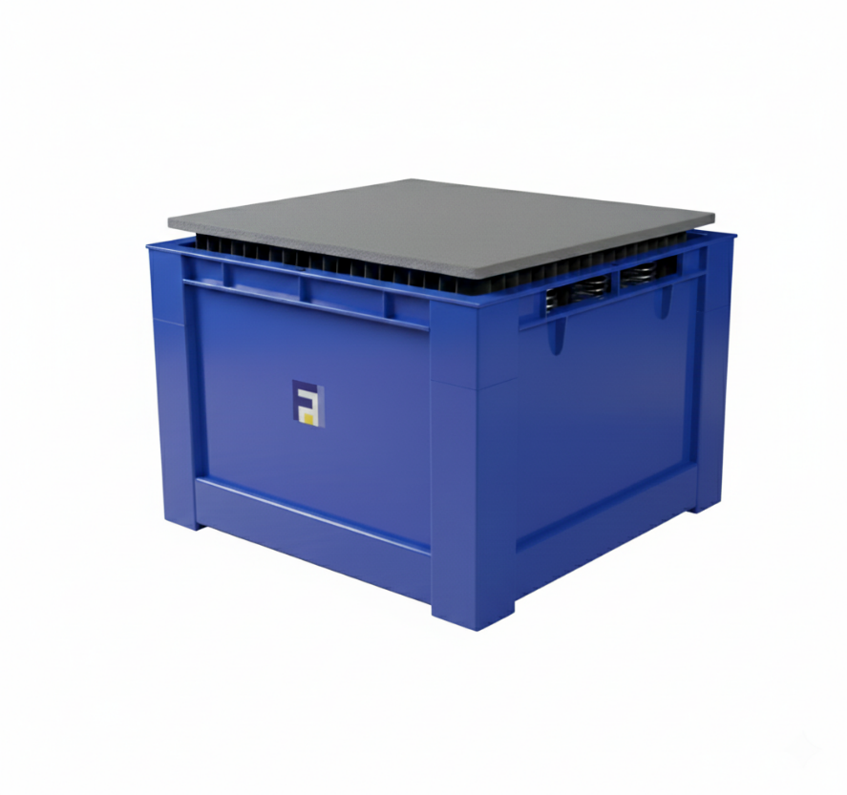

Spring Loaded Bins

Picture for reference

A spring-loaded bin is a self-leveling collection bin, Falcon’s SLB is an ergonomic material handling solution designed to maintain a consistent working height for its contents. As items are removed or added, the internal platform automatically adjusts up or down, ensuring that the top layer of materials is always at an optimal level for the user.

Key Features and Description:
1. Ergonomic Design:
2. Self-Leveling Mechanism
3. Durable Construction
4. Versatility

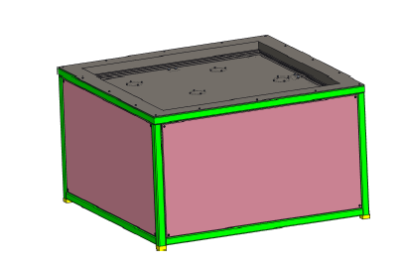
Technical Specification

ISO View

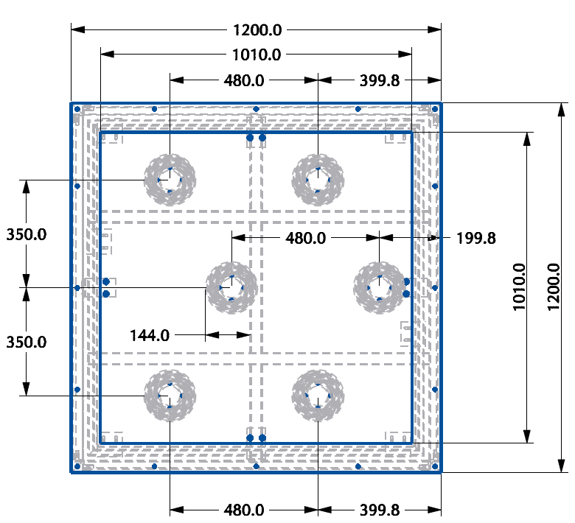

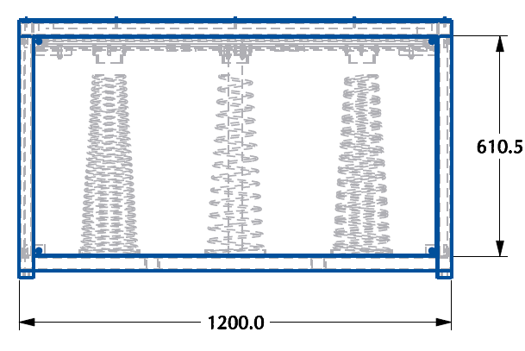

Side View
Top View

Sope of Supply

Mechanical BOM

Pos. | Qty. | Description | Value
FM1 | 1 | Spring Loaded Bins | 05 Nos

Service

Pos. | Qty. | Description | Value
FS1 | 1 | Installation & Commissioning  The Installation is carried out by specialists of supplier based on an agreed lump sum – for a normal working time of 10 hours per day and 6 days per week – also includes.  - Board & Lodging  - Travel Expenses  - Insurance  - Tools | Inclusive

Program Organization

Delivery Schedule

Dispatch within 6-8 weeks from the date of signed PO & advance received.

Commercial Terms

Price Sheet

S. No. | Description | Qty | Unit Price (INR) | Amount (INR)
1 | Spring Loaded Bin | 5 | ₹ 50,400 | ₹ 2,52,000
2 | Packaging & forwarding | 5 | ₹ 1,260 | ₹ 6,300
3 | Installation and Commissioning | 5 | ₹ 2,520 | ₹ 12,600
4 | Freight till Site (Manesar) | 1 | ₹ 15,000 | ₹ 15,000
Grand Total |  |  |  | ₹ 2,85,900

The Total Price is to be understood.

    - Freight charges - Included.
    - Taxes : GST @18%
    - Packing and Forwarding - Included
    - Duty unpaid
    - Installation and Commissioning: Included.
    - Price is valid for 30 days from the date of the proposal.

Our Price does not include taxes, and duties, import duties, charges, fees, taxes etc. charged by authorities outside India for deliveries and services. The same shall be borne & paid by client itself.
*Material Unloading & Laydown area is in customer scope

Payment Terms

The Supplier Quotation is based on the following payment schedule: Stage 1: 100% Advance along with PO.

Warranty Period

Falcons offered System comes with a standard warranty of 1 year and post completion of warranty, customer can opt for Extended warranty. Warranty covers the following support:
- Telephonic, Email and Remote Service Support when required.
- Regular Software updates and Bug Fixes.
- Supply of Mechanical and Electrical components in case of failure (excluding damages as mentioned in Exclusion Clause)
The warranty does not apply to replacement or repair of:

- Faulty articles:
  - Failure to comply with the manufacturer's recommendations (logistics documentation, Technical Information Note, retrofit document) and the rules of the trade.
  - Negligence or abnormal use of equipment.
  - Anomalies produced by an environment of use, storage or transport that does not comply with the specifications or recommendations of Falcon: packaging, temperature, hygrometry, sector, insulation, etc.
  - A defect due to a cause external to the supplies and services of Falcon.
- Equipment other than that supplied by Falcon.
- Items that can be repaired exclusively by Falcon that have been repaired or attempted repairs other than those carried out by Falcon.
- Items that fail due to normal wear and tear of one or more of its components or whose tamper- evident seals (varnish, strip, etc.) have been broken or whose serial numbers have been removed or modified.

